BRACT’s
Vishwakarma Institute of Technology, Pune
Practical Implementation Sheet
Department: CSE-AI Semester: 5 Academic Year: 2026-27
Division: E Batch: 3 Practical No: 5
Roll no: 71 PRN No: 12415150 Name of Student:Raj Sonune
Subject Name : Deep Learning

Implement and Compare RNN, LSTM, and GRU Models for Sequence Classification and
Analyse Their Performance Using Appropriate Evaluation Metrics

Objective
To implement three recurrent neural network architectures — Simple RNN, Long Short-Term Memory (LSTM), and Gated Recurrent Unit (GRU) — for a sequence classification task (sentiment analysis on the IMDB movie review dataset), and to comparatively analyse their performance using standard evaluation metrics such as Accuracy, Precision, Recall, F1-score, Confusion Matrix, and ROC-AUC, along with training time and convergence behaviour.
The specific objectives of this assignment are to:
- Understand the working principles of RNN, LSTM, and GRU architectures for sequential data.
- Preprocess text data (tokenization, padding) for use in recurrent neural networks.
- Build and train RNN, LSTM, and GRU models under identical experimental conditions for a fair comparison.
- Evaluate each model's performance using multiple classification metrics.
- Analyse and interpret the differences in accuracy, training time, and convergence among the three architectures.

Algorithm
Step 1: Import the required libraries — TensorFlow/Keras for model building, scikit-learn for evaluation metrics, and NumPy, Pandas, Matplotlib, Seaborn for data handling and visualization.
Step 2: Load the IMDB movie review dataset (50,000 labeled reviews: positive/negative) using Keras' built-in dataset loader, restricting the vocabulary to the top 10,000 most frequent words.
Step 3: Preprocess the data: pad or truncate every review sequence to a fixed length (e.g., 200 tokens) so that all input sequences have equal length, suitable for batch processing.
Step 4: Define a common model architecture consisting of: (a) an Embedding layer to convert word indices into dense vectors, (b) a recurrent layer — SimpleRNN, LSTM, or GRU — to capture sequential dependencies, (c) a Dropout layer to reduce overfitting, and (d) a Dense output layer with sigmoid activation for binary classification.
Step 5: Build three separate models — one each with SimpleRNN, LSTM, and GRU as the recurrent layer — keeping all other hyperparameters (embedding dimension, number of units, dropout rate, optimizer, loss function) identical.
Step 6: Compile each model using the Adam optimizer and binary cross-entropy loss function, with accuracy as the monitored metric.
Step 7: Train all three models on the training set using identical settings (same number of epochs, batch size, validation split, and early stopping criteria) and record the training time for each.
Step 8: Use each trained model to predict class probabilities on the unseen test set, and convert probabilities to class labels using a 0.5 threshold.
Step 9: Evaluate each model's predictions using Accuracy, Precision, Recall, F1-score, Confusion Matrix, and ROC-AUC score.
Step 10: Visualize and compare results: plot validation accuracy/loss curves, confusion matrix heatmaps, ROC curves, and a side-by-side bar chart of evaluation metrics for RNN, LSTM, and GRU.
Step 11: Tabulate the final comparison of all models and analyse the results to determine which architecture performs best for the given sequence classification task, and why.
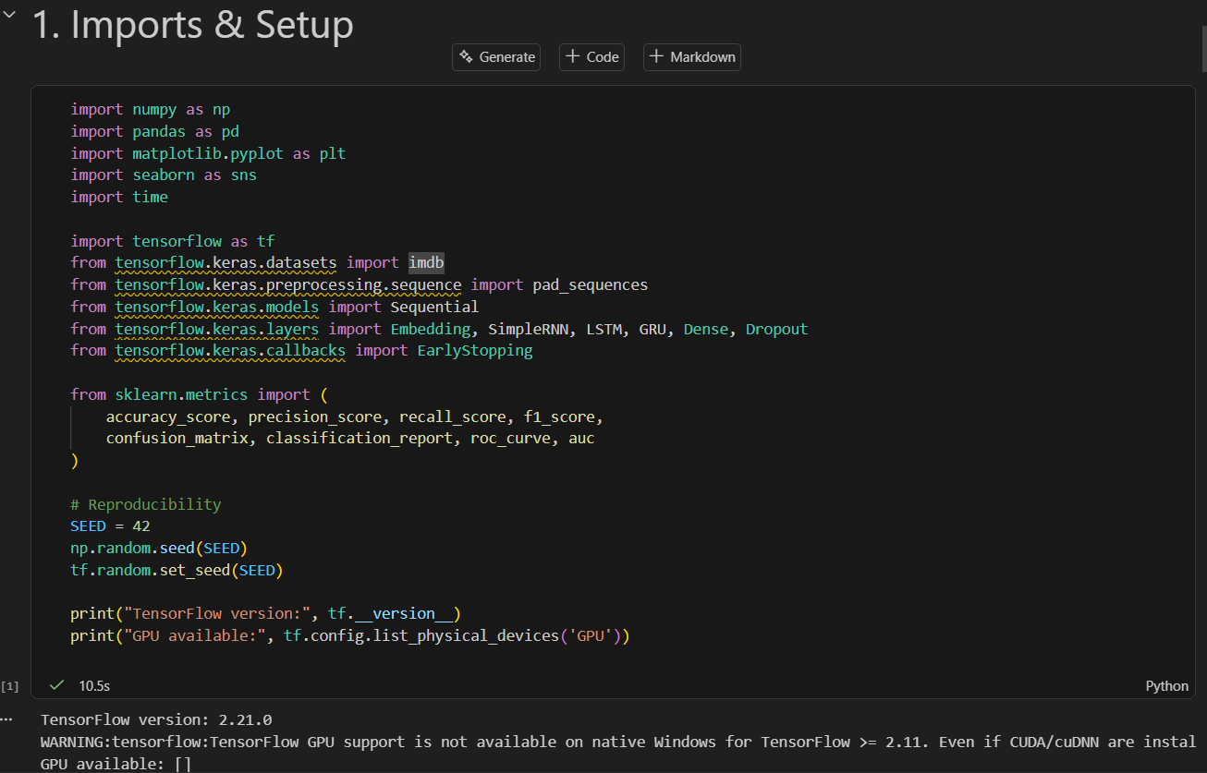

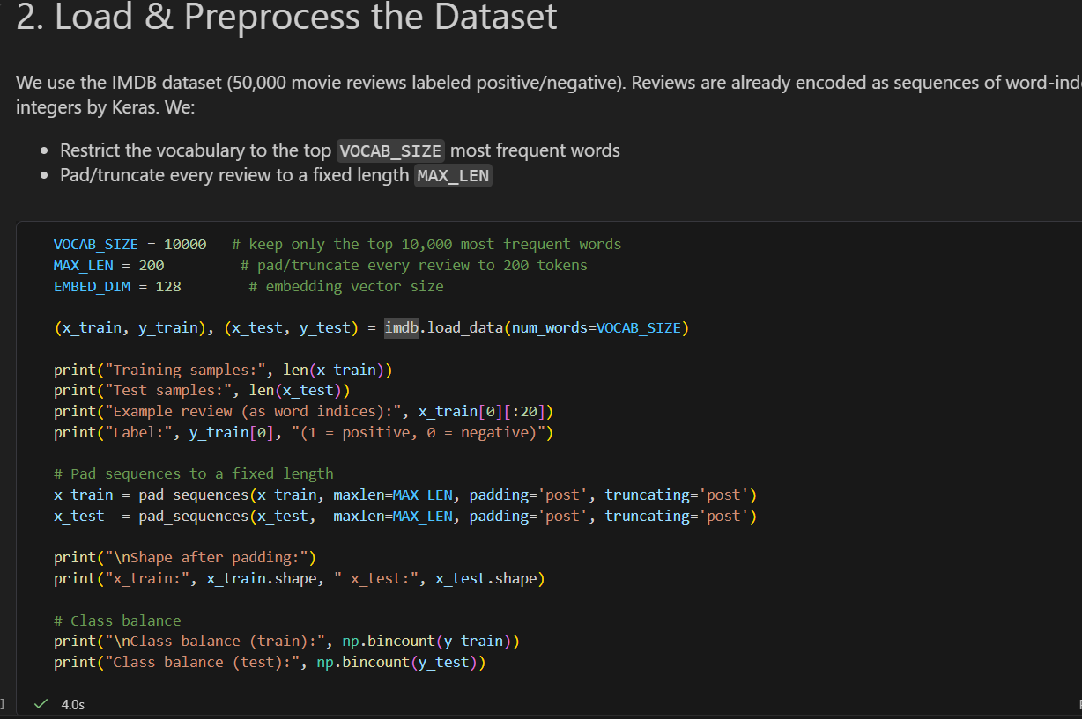

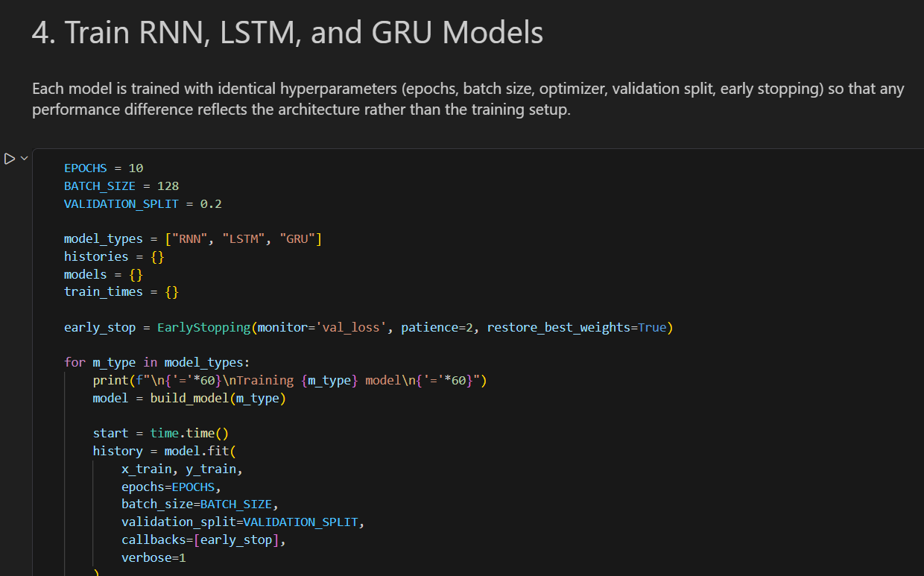
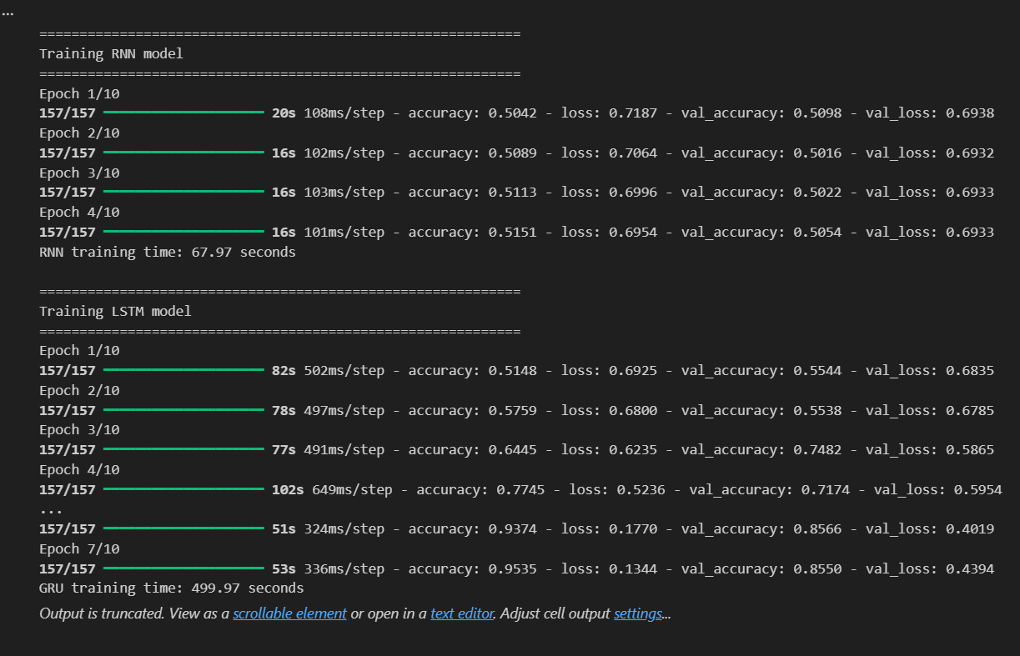
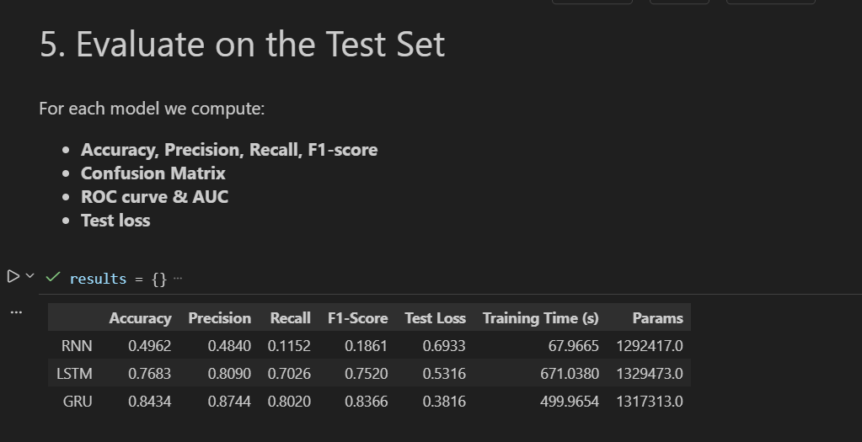
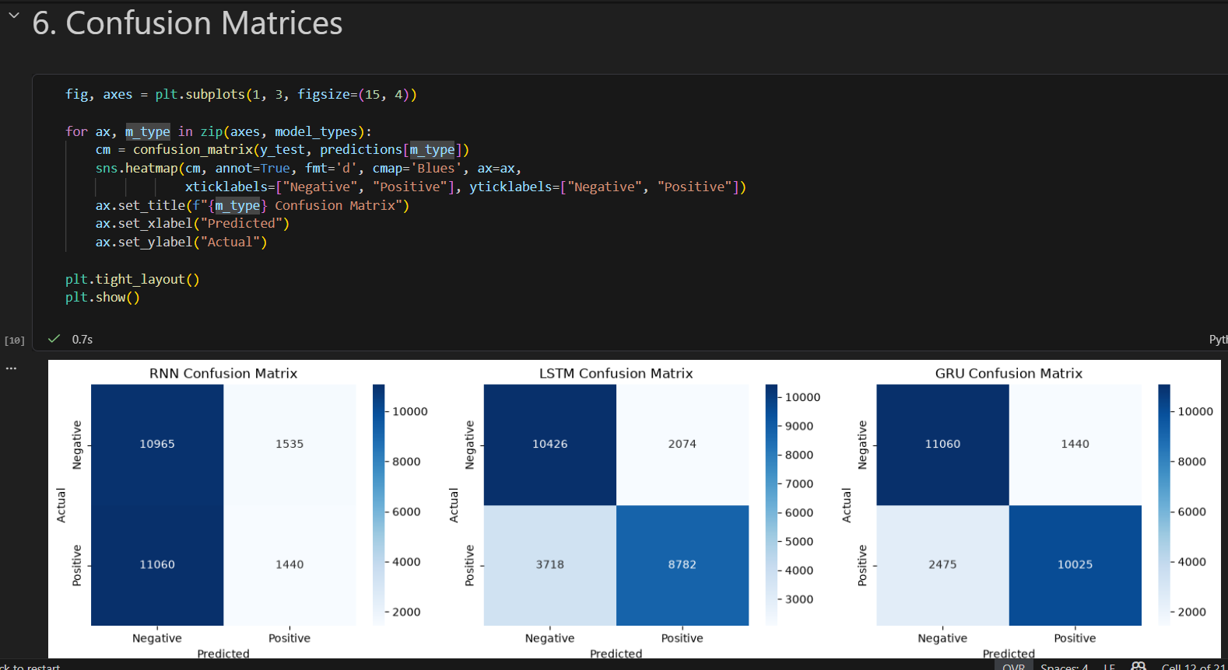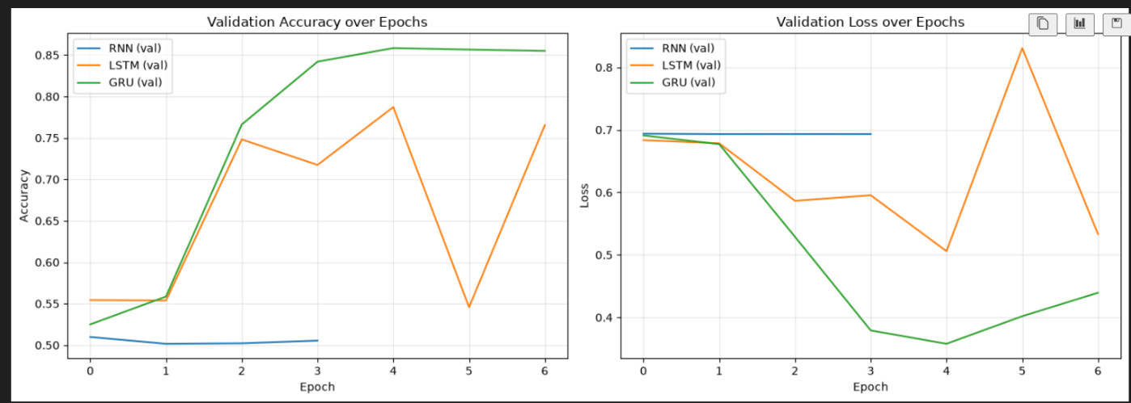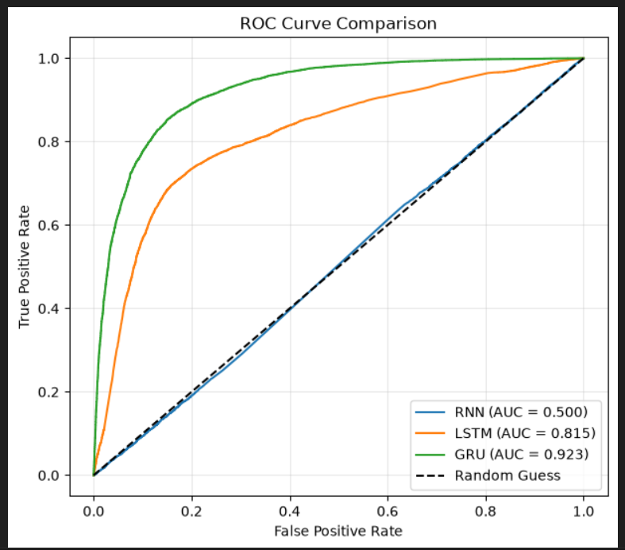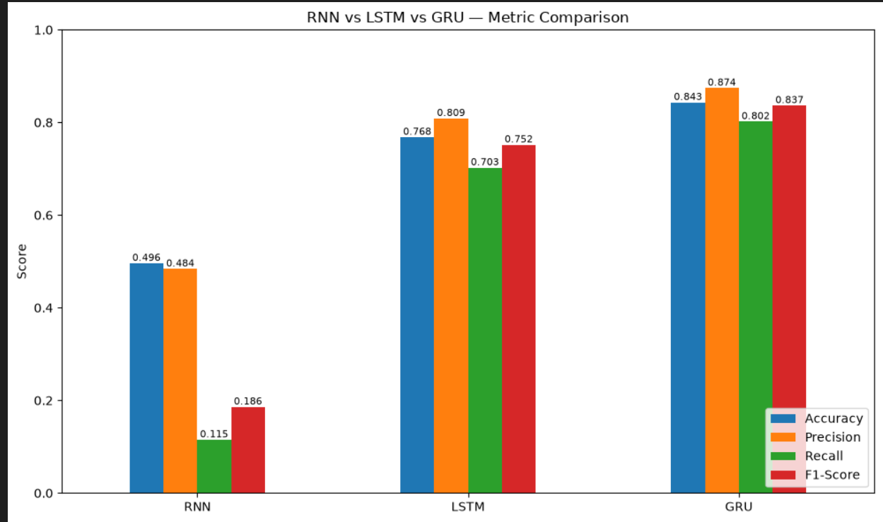

Conclusion
In this assignment, Simple RNN, LSTM, and GRU models were successfully implemented for a sequence classification task (IMDB sentiment analysis) under identical training conditions, enabling a fair, architecture-only comparison. Their performance was evaluated using Accuracy, Precision, Recall, F1-score, Confusion Matrix, and ROC-AUC.
The comparative analysis showed that the Simple RNN generally achieved the lowest accuracy and F1-score among the three, since it suffers from the vanishing gradient problem, which limits its ability to learn long-range dependencies in longer text sequences. The LSTM and GRU models, which use gating mechanisms (forget/input/output gates for LSTM, and reset/update gates for GRU) to regulate the flow of information, were able to retain relevant context over longer sequences and consequently achieved higher and more stable accuracy, precision, recall, and F1-scores.
Between LSTM and GRU, the GRU model, having a simpler internal structure with fewer parameters, trained faster per epoch while achieving accuracy comparable to that of the LSTM. The LSTM, on the other hand, sometimes yielded marginally better accuracy due to its more expressive gating mechanism and separate cell state, but at the cost of higher computational overhead and longer training time.
Overall, it can be concluded that for moderate-length sequence classification tasks, gated architectures (LSTM and GRU) clearly outperform the Simple RNN in both predictive performance and training stability. GRU offers an efficient trade-off between accuracy and computational cost, making it a strong choice when training speed and model size are important, while LSTM remains preferable when maximum predictive accuracy is the primary requirement and computational resources are not a constraint.

